NAME :P.kalyan

REG NO :192110675

COURSE :software engineering

CODE :CSA1001

FACULTY :Mary valantina

DATE :29/9/2022

**LAB MANUAL 17 TO 24**

**EXPERIMENT:17**

17.Draw and validate the flowchart to compute the quotient and remainder.

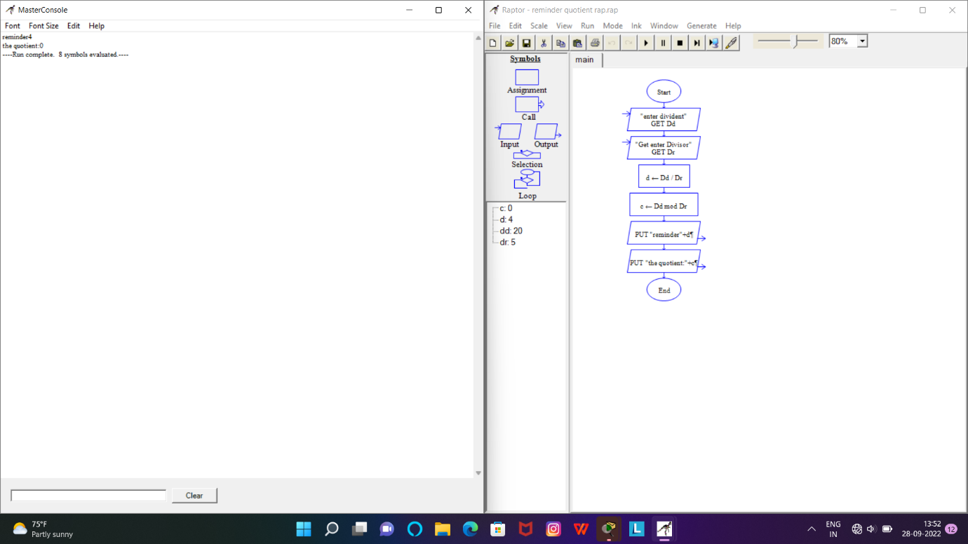

RESULT:Successfully designed this experiment using raptor tool

**EXPERIMENT:18**

18.Using Raptor- Draw and validate the flowchart to calculate Fibonacci series

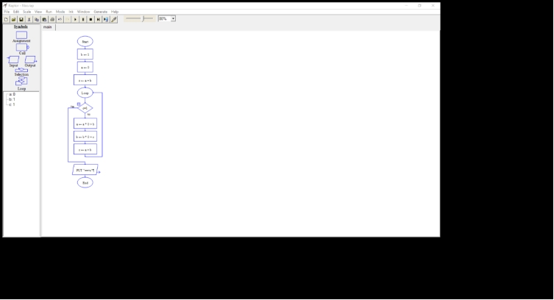

RESULT:Successfully designed this experiment using raptor tool

Experiment:19-Using Raptor- Draw the flowchart to check whether the given number is a palindrome or not.

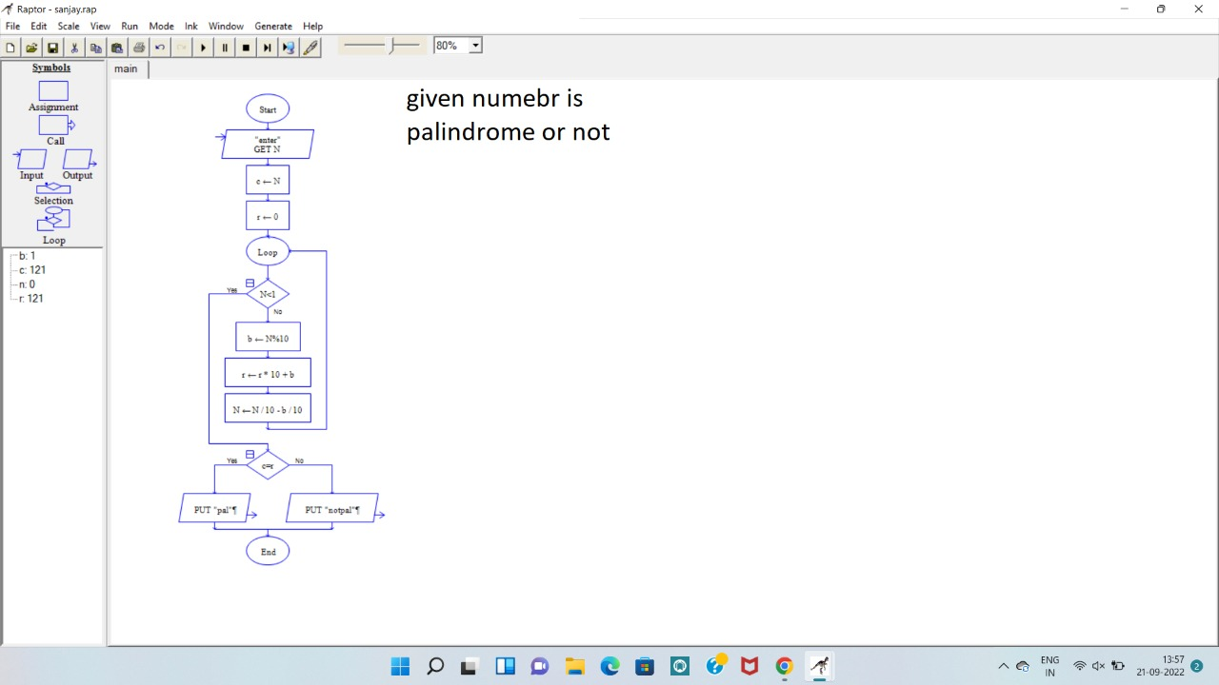

**Result: this program ie verified and executed successfully**

**EXPERIMENT:20**

20.Using Raptor – Draw and validate the flowchart to swap two characters.

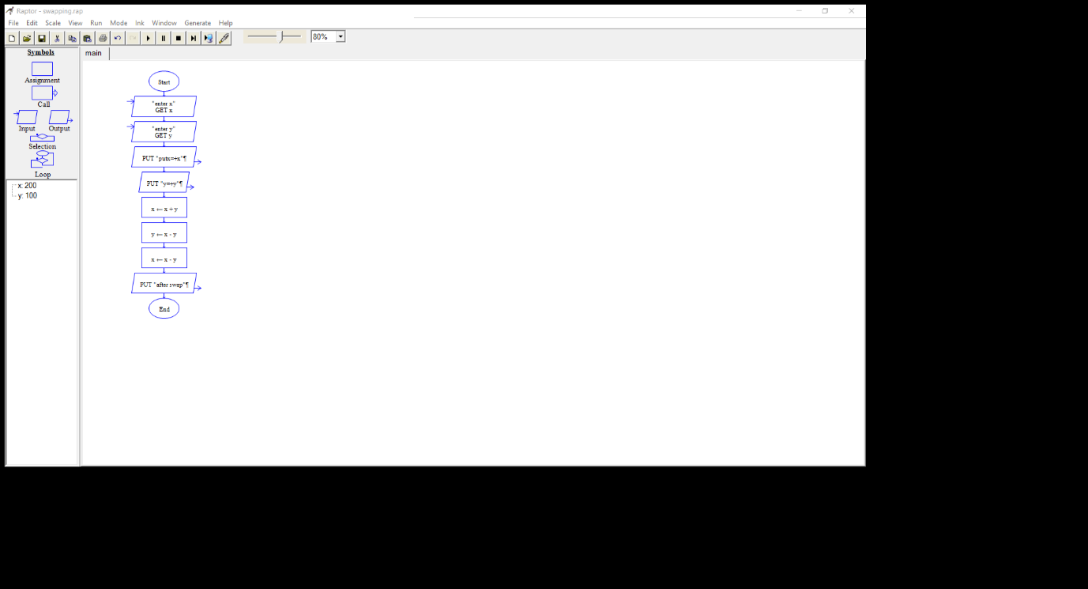

RESULT:Successfully designed this experiment using raptor tool

**EXPERIMENT:21**

21.Using Raptor – Draw the flowchart to display the length of the string.

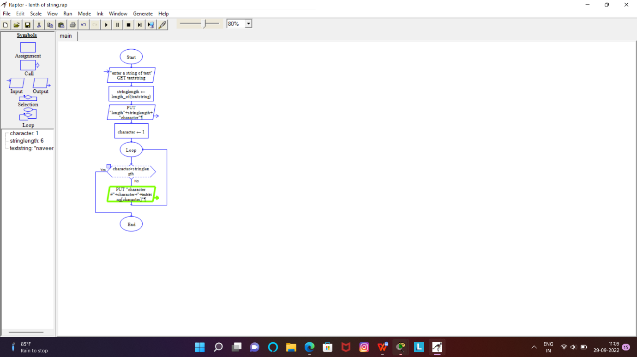

RESULT:Successfully designed this experiment using raptor tool

**EXPERIMENT:22**

22.Using Raptor – Draw the flowchart to find whether the given number is prime or not.

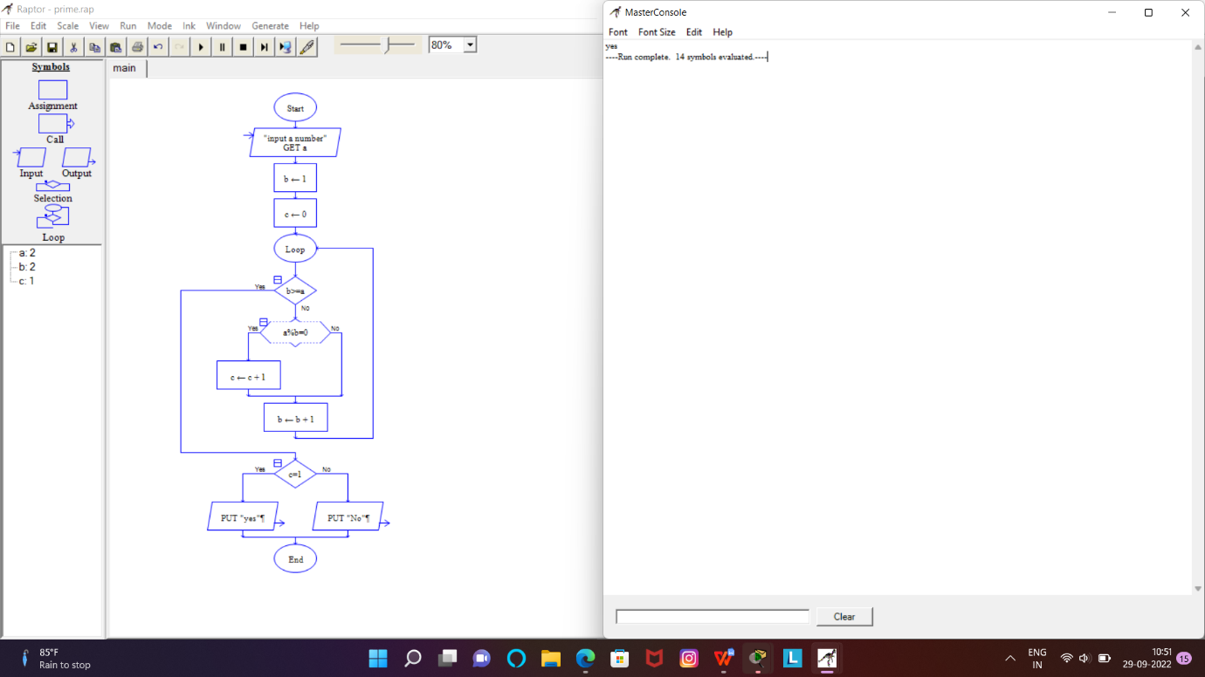

RESULT:Successfully designed this experiment using raptor tool

Experimental:23-Find Cyclomatic Complexity for a graph having number of edges as 12, number of nodes as 13 and number of predicate nodes in the flow graph as 5.

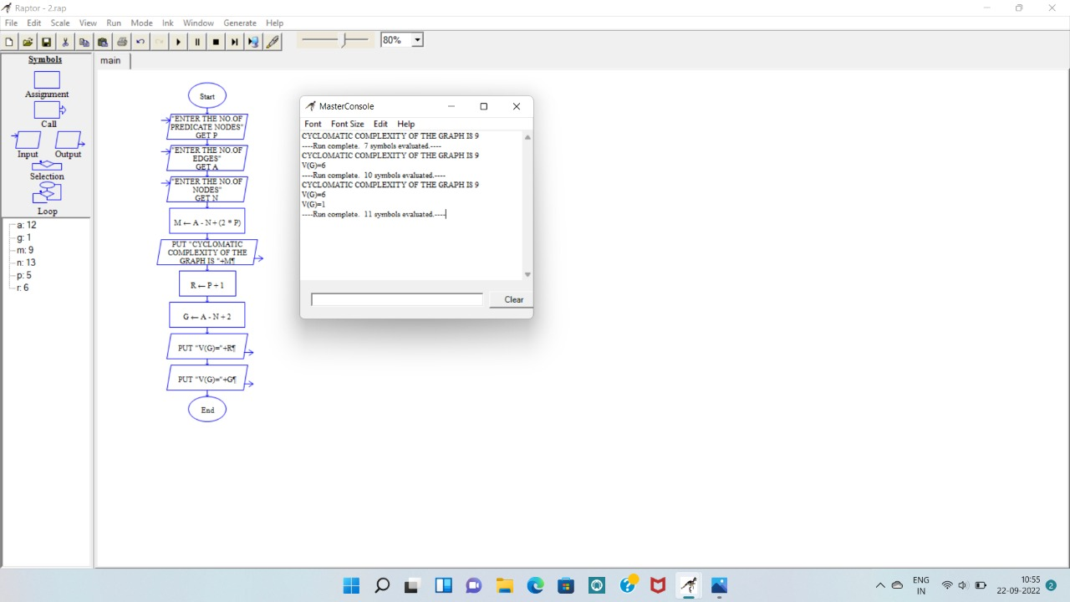

Result: this program is verified and executed succesfully